# Week 5.1

## Camera Manager Update

* Update the SetActiveCamera method of CameraManager

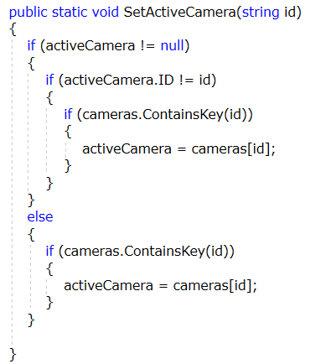

## Game 1

* Update the Initialize method of Game1

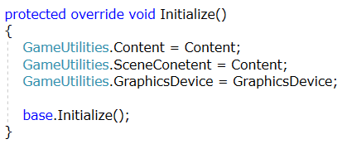

# Engine

## Components

* Create 4 new folders in the Engine project
  + Components
    - Cameras
    - Graphics
    - Input
* Download FixedCamera and BasicEffectModel from Moodle

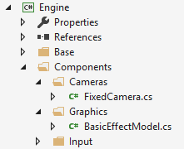

# Client

* Create three new folders in the Client project
  + Create the three new classes shown below

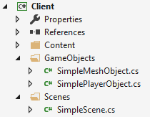

## Simple Mesh Object

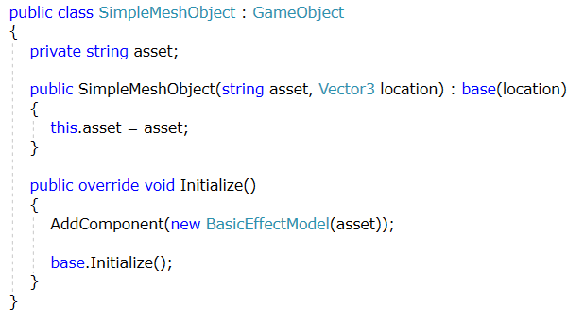

## Simple Player Object

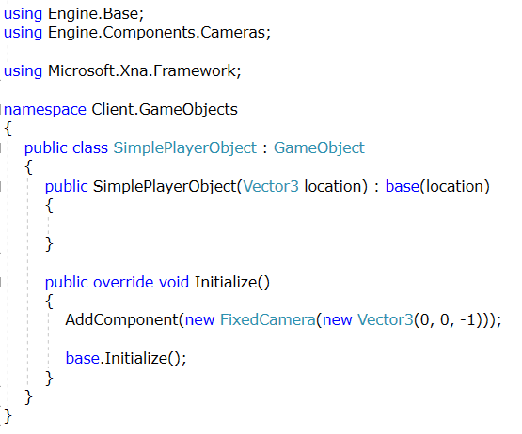

## Simple Scene

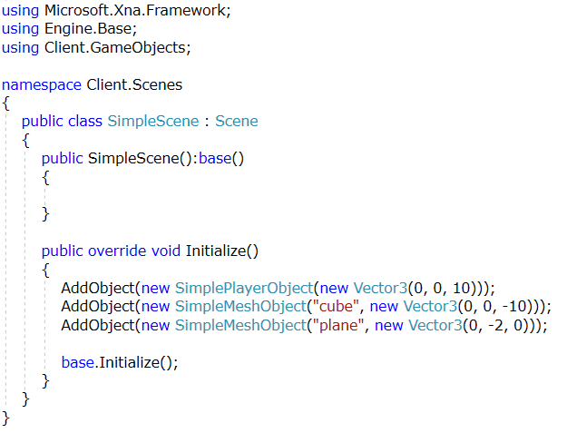

## Load Scene in Game1

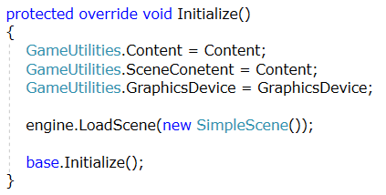

# Content

* Download the files in the Week 5.1 Content folder on Moodle
* Add this content to your Content Project. **Your folder structure must match the image below**

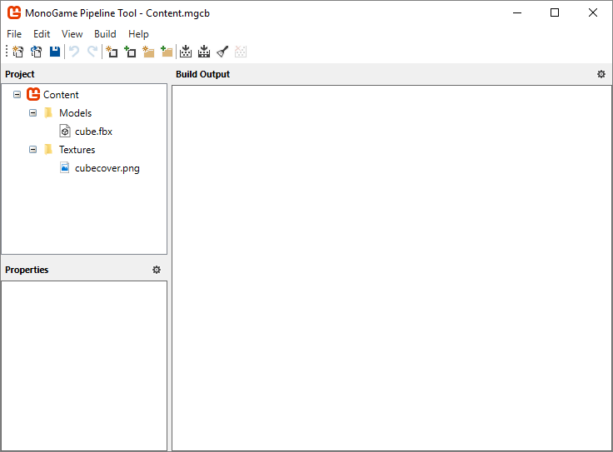

# Expected Result

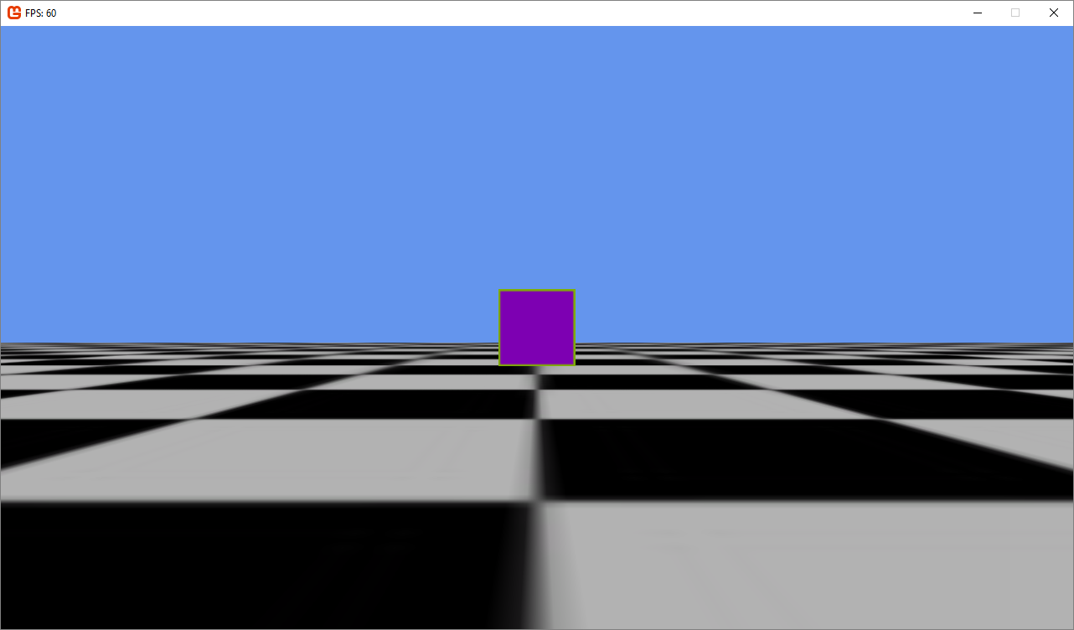

# Input Script

## Player Movement Controller

* Create a new class called PlayerMovementController

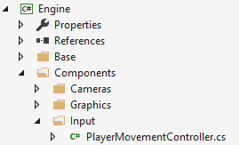

* Player Movement controller will inherit from ScriptComponent (Component will work too)
* This component is responsible for detecting keyboard input and moving a GameObject from this input
  + A key should move the object left
  + D key should move the object right
  + W key should move the object forward
  + S key should move the object backward
* Hints
  + Owner.World stores our transformations
  + Matrix.CreateTranslation
  + Time.DeltaTime

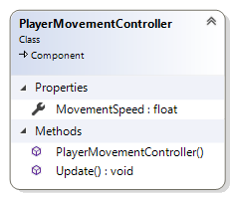

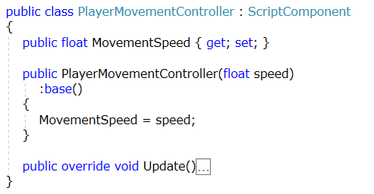

## Simple Player Object

* Update SimplePlayerObject to now include this script

